LAB #7
Efe Emir Cesur
Student ID #: 22608
Lab Section : A
1. Introduction
In this experiment, the primary goal is to characterize the behavior of a Bipolar Junction Transistor (BJT) and to design and implement a single-stage common-emitter amplifier. The laboratory session aim to extract the fundamental input-output characteristics of a BJT using a curve tracer circuit. Furthermore, the experiment focuses on establishing the DC operating conditions of the amplifier and analyzing its small-signal behavior, voltage gain, and bandwidth.
To understand the circuit behaviors observed in this lab, theoretical information including the system sub-blocks is given:
- BJT Curve Tracer: This circuit allows for the extraction of the IC-VBE and IC-VCE characteristics. By measuring the voltage drops across resistors, the collector and emitter currents can be deduced for various base-emitter voltages. This data is important for determining transistor parameters, including the source current and the common-emitter current gain .
- Common-Emitter Amplifier: This is a widely used BJT amplifier configuration known for providing voltage gain. Its design requires DC biasing to establish a desired operating point.
- Emitter Degeneration and Bypass Capacitors: An emitter resistor (RE) provides negative feedback to limit the effects of internal emitter resistance (re) variability on the gain. An emitter bypass capacitor (CE) can be introduced to short the emitter to ground for AC signals, thereby increasing the midband gain at the cost of altering the frequency response.

2. Pre-Lab Work

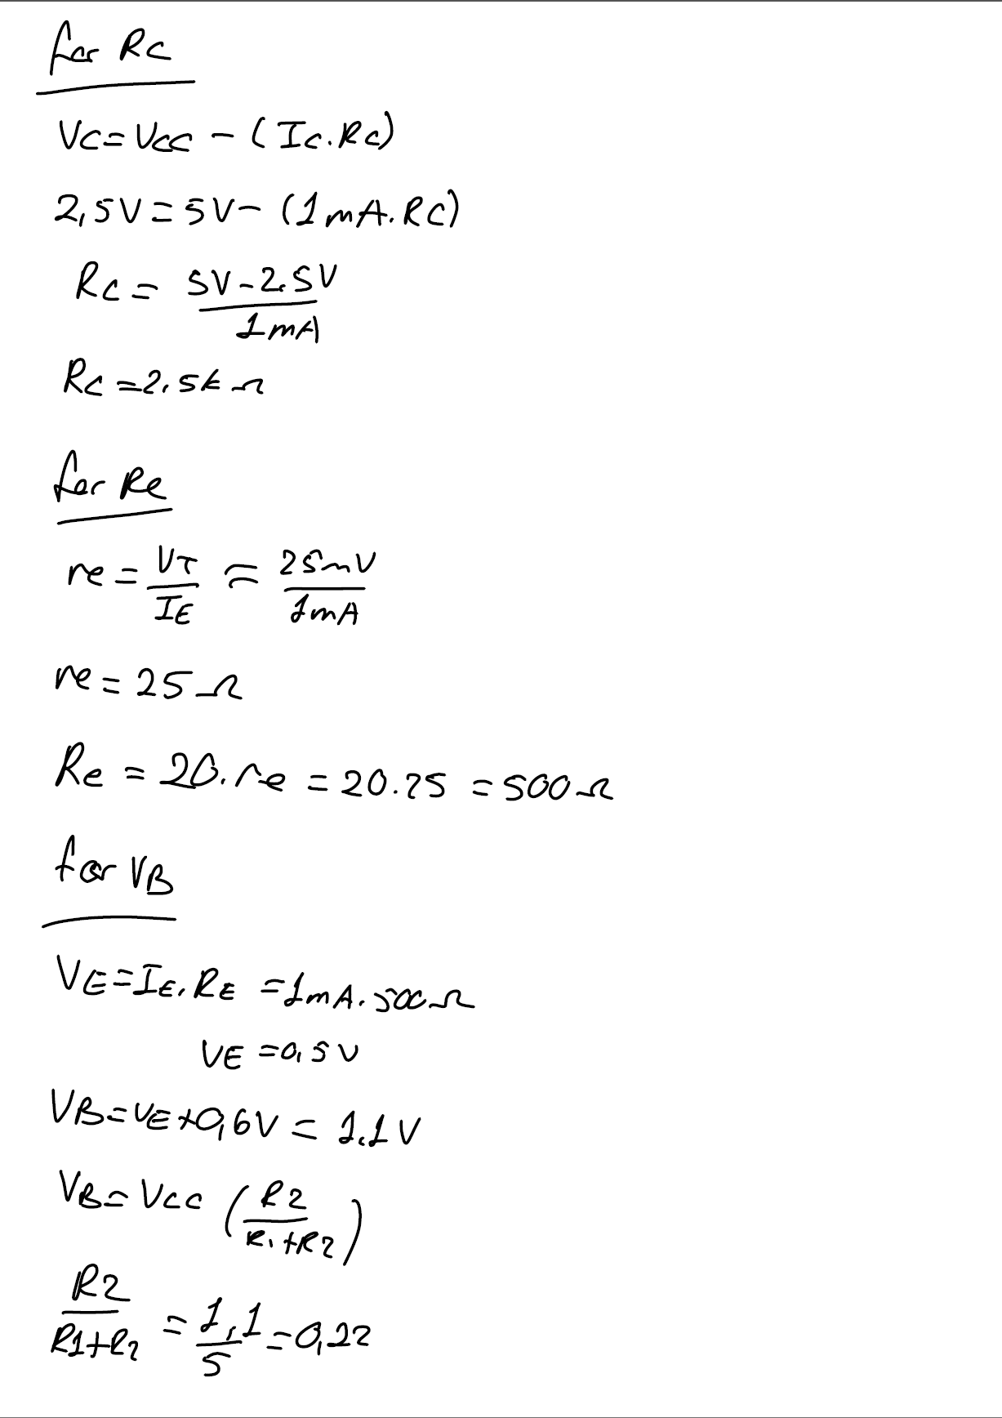
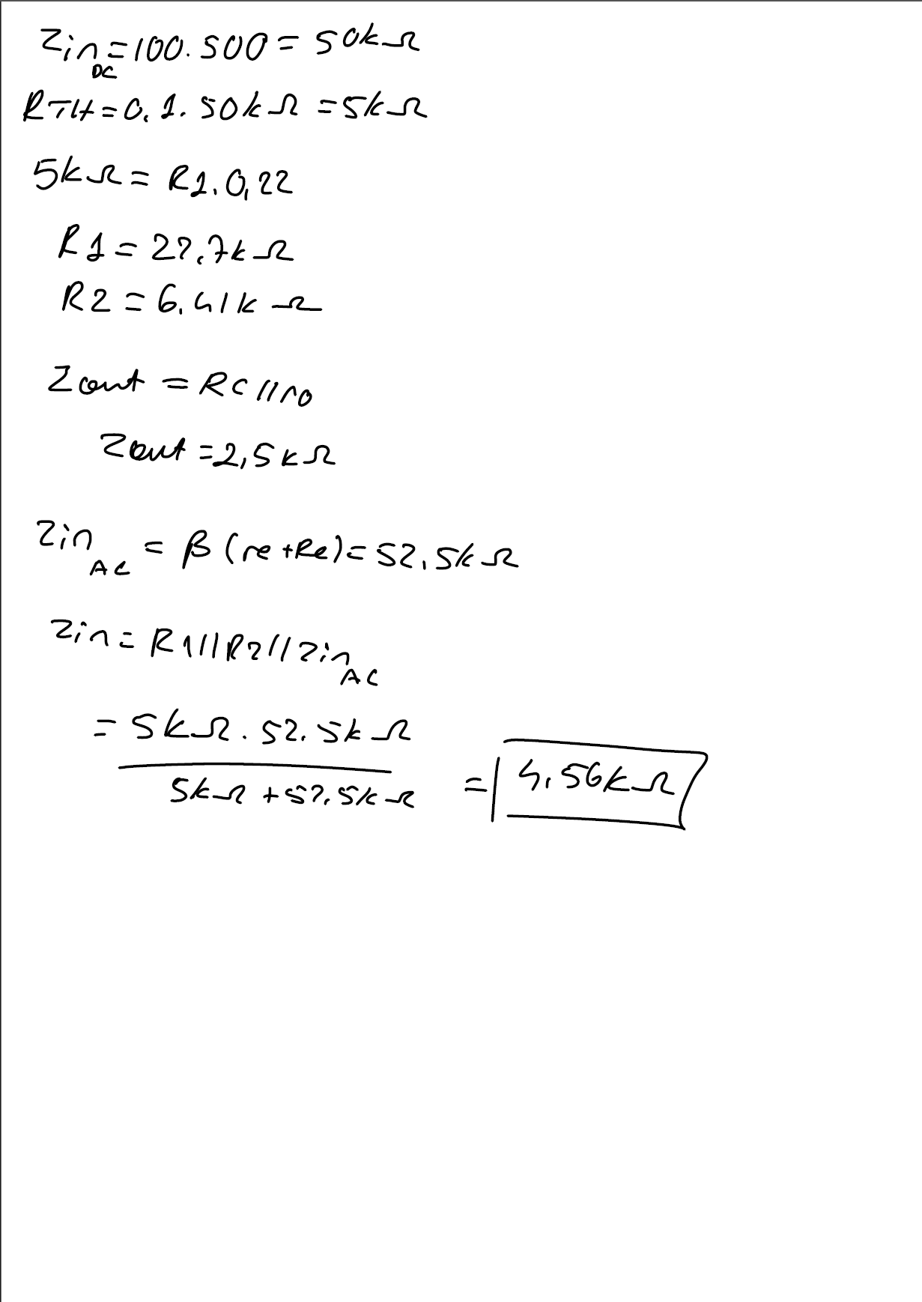
3. Data/Results
Part 1 – BJT Curve Tracer
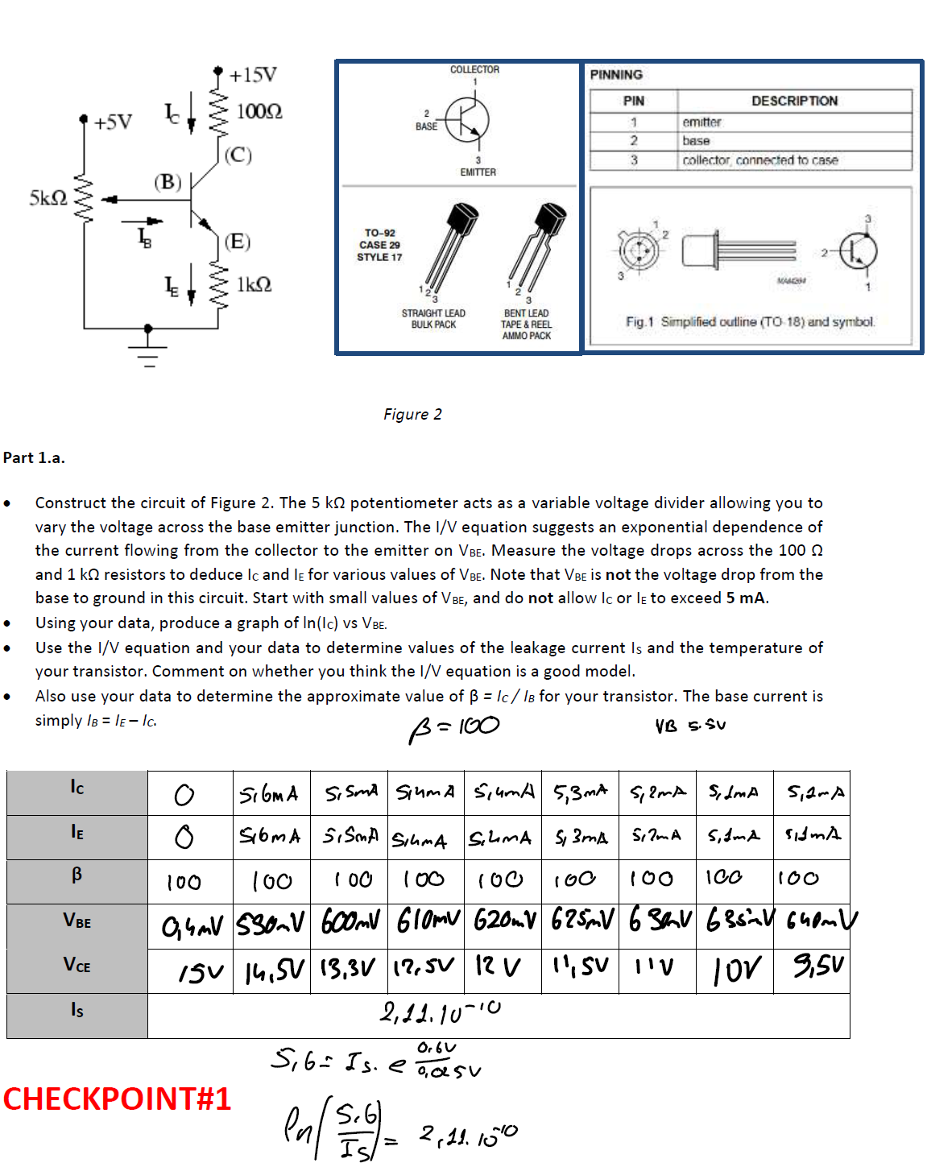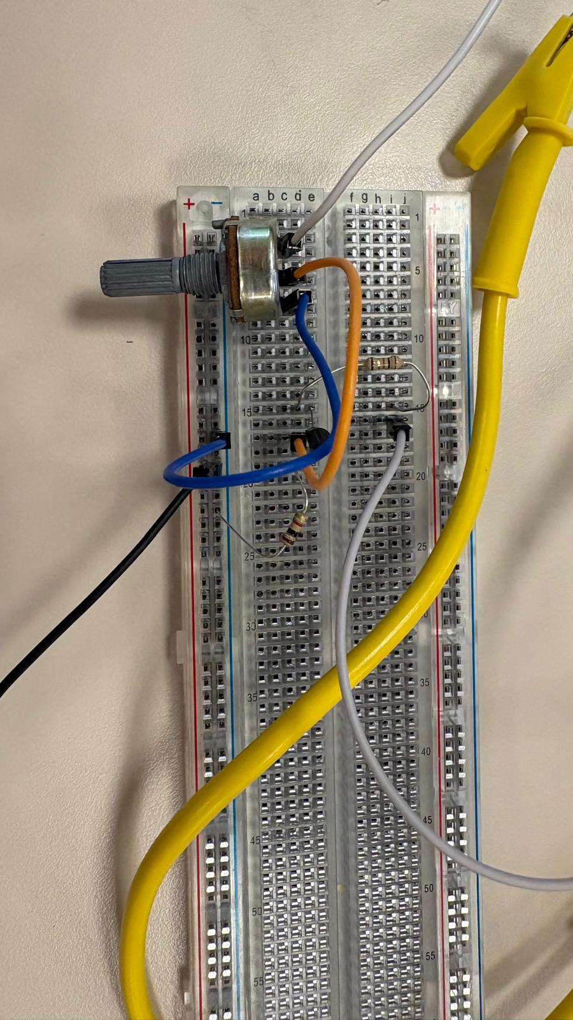
Figure 1: Circuit for the first BJT Curve Tracer
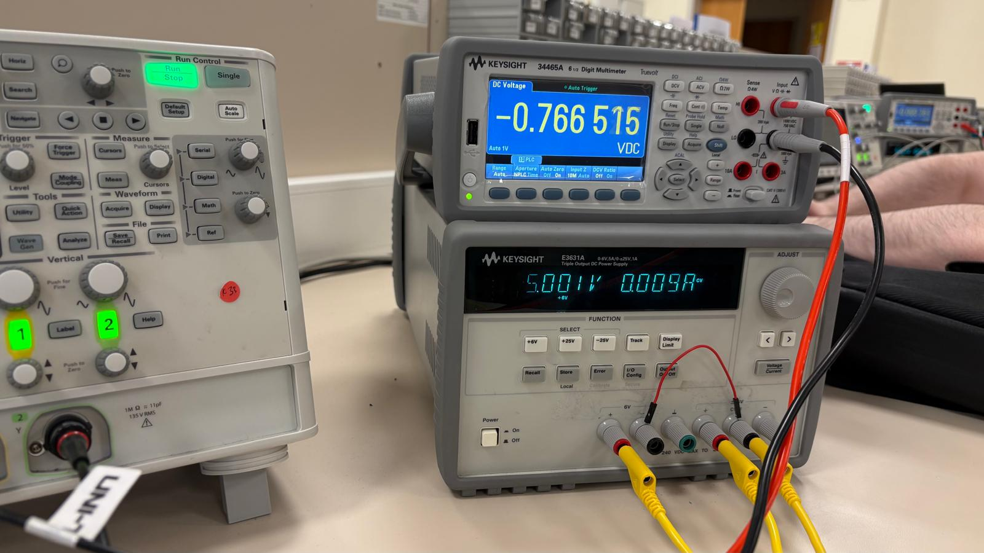
Figure 2: Measurement for the first circuit
BJT Curve Tracer circuit is built using a BJT, 100 ohm, 1k ohm and 5k ohm.
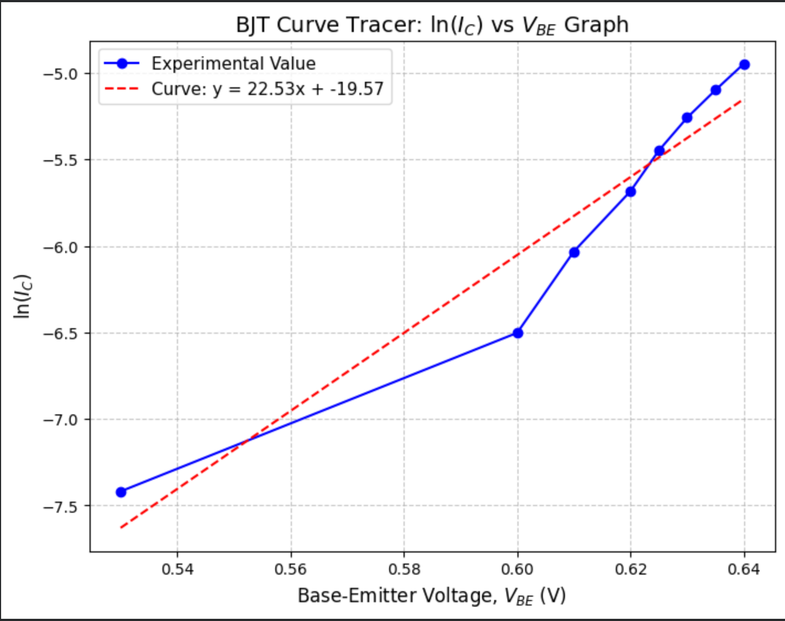

Part – 2 BJT Common-Emitter Amplifier
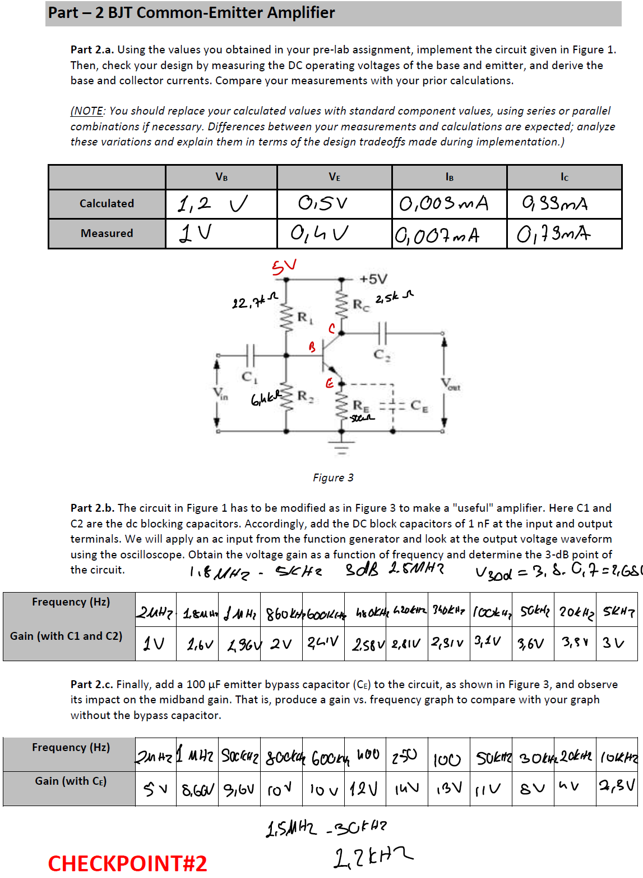

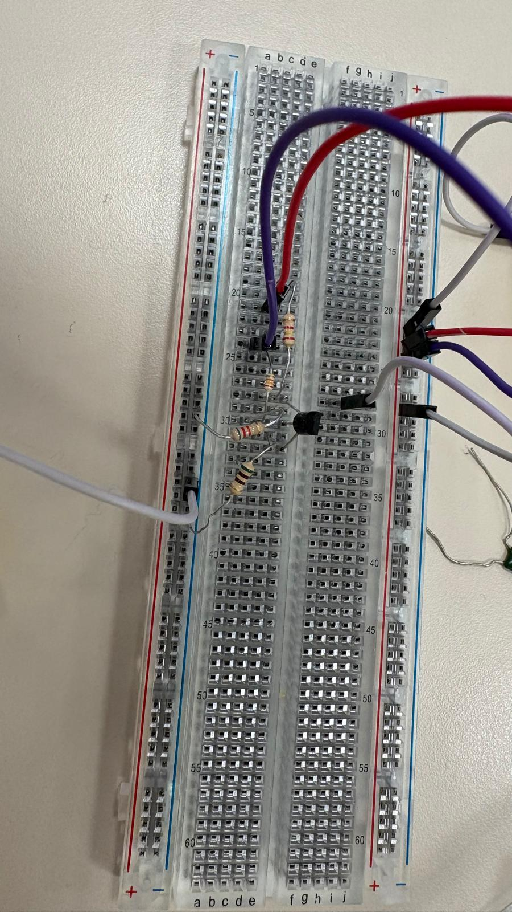
Figure 3: Circuit for BJT Common Emitter Amplifier
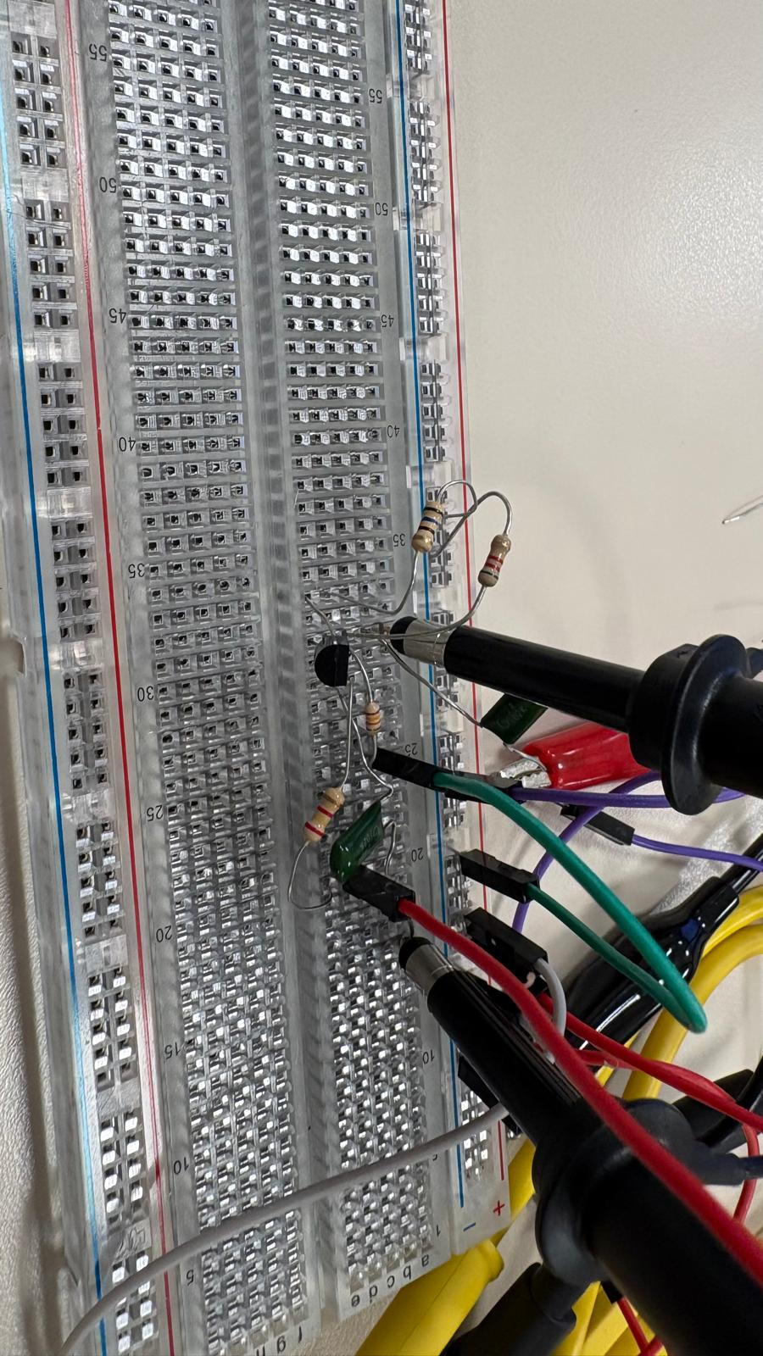
Figure 4: Circuit for BJT Common Emitter Amplifier
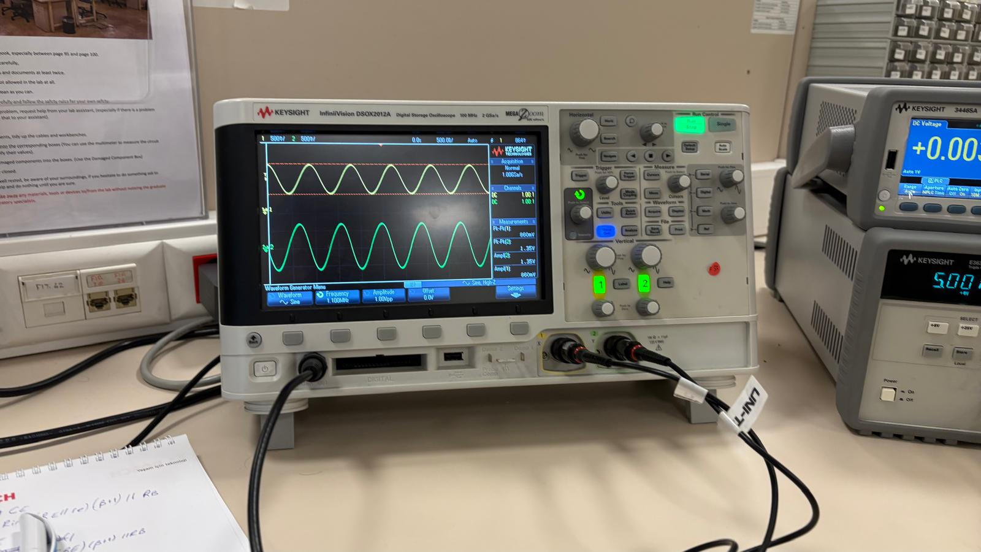
Figure 5: Measurements for BJT Common Emitter Amplifier
BJT Common Emitter Amplifier circuit is built using 12.7k ohm, 2.5k ohm, 6.4k ohm, 500 ohm and 10nF capacitors.
4. Discussion
The experimental results obtained from the implementation of the BJT circuits provide an analysis of transistor characteristics and amplifier performance. In the first part of the experiment, the curve tracer successfully allowed for the extraction of the transistor parameters. The expected exponential relationship between the collector current and the base-emitter voltage was observed. By analyzing the collector current (IC) versus VBE data, the approximate value of Beta and the leakage current (IS) were determined.
In the second part, the common-emitter amplifier was implemented using standard component values that closely matched the theoretical calculations. When verifying the DC operating conditions, minor differences between the theoretical predictions and the experimental measurements of the base and emitter voltages (VB, VE) were observed. These variations can primarily be attributed to the tolerances of the physical resistors used in the biasing network and the inherent manufacturing variations in the Beta value of the transistor. Furthermore, while the base-emitter voltage drop is theoretically assumed to be approximately 0.6 V for biasing calculations, the actual VBE varies slightly depending on the operating current and temperature.
The AC analysis of the amplifier demonstrated the frequency-dependent behavior of the circuit. The addition of the DC blocking capacitors (C1 and C2) established the lower cut-off frequency, allowing for the determination of the 3-dB bandwidth. When the emitter bypass capacitor (CE) was introduced, a significant impact on the midband voltage gain was observed, validating the theoretical premise that bypassing RE removes local AC negative feedback.
The implication of these variations for practical electronic circuit design is that engineers must account for component tolerances and non-ideal behaviors.
5. Conclusion
In this experiment, the DC and AC characteristics of BJT circuits were successfully analyzed and implemented. The lab work integrated fundamental electronic concepts, including transistor device characterization, DC biasing, and small-signal amplification. The design specifications, particularly establishing a 1 mA collector current and centering the output voltage at 2.5 V, were achieved within acceptable margins of error.
The transition from theoretical calculations to workbench implementation highlighted the importance of considering design tradeoffs, such as balancing input impedance with stable biasing. Overall, the experiment clarified the theoretical principles of BJT operation, demonstrating how precise DC operating conditions combined with appropriate coupling and bypass capacitors result in a stable, functional common-emitter amplifier.

